Activity Diagram and Sequence Diagram

Name : Vyom Pathak

ID : 17CEUON038

Roll No. : CE099

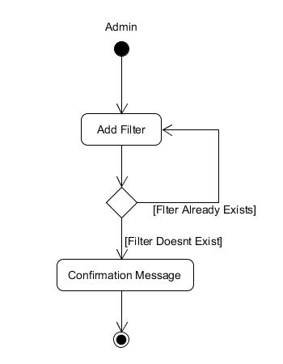

Add Filter Activity

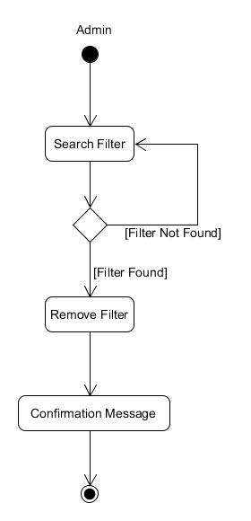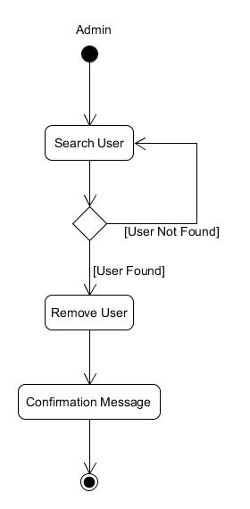

Remove Filter Activity Remove User Activity

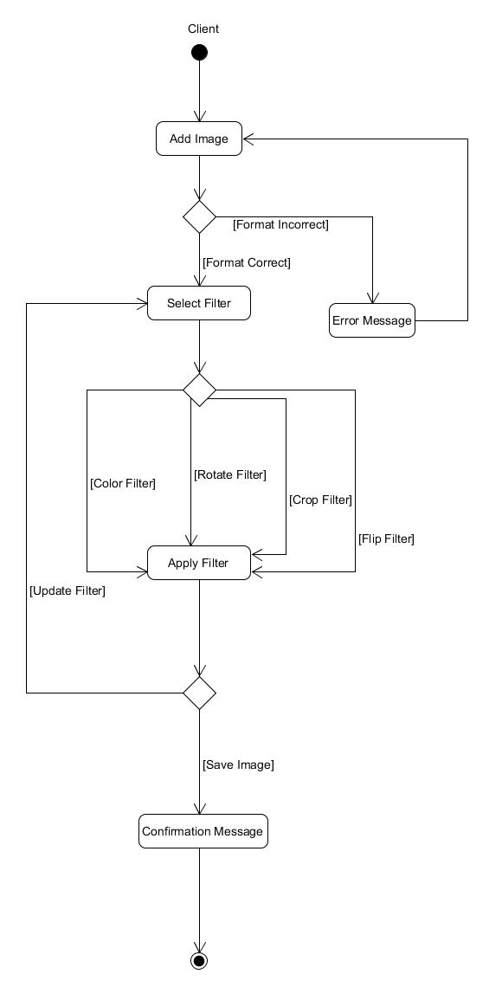

Apply Filter Activity

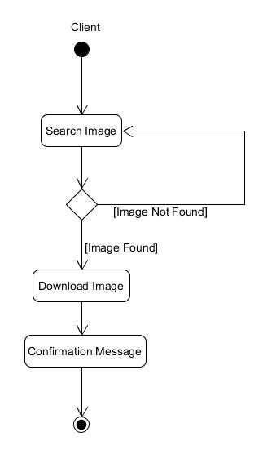

Download Image Activity

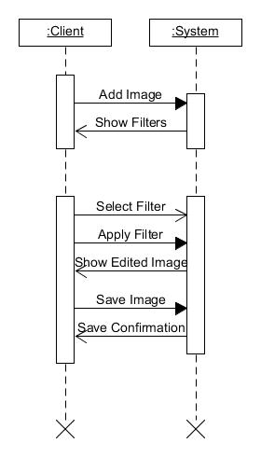

Apply Filter Scenario